**CSCI 401 Project Meeting Minutes 3**

Time: 10:10 PM-00:00 AM

Date: Sep 3rd 2017

Location: Online (Google Hangouts)

Attendance: James Tseng, Yining Huang, Mian Lu, Nelson Lin

Agenda:

* Address frontend and backend ideas for Proof of Concept
* Frontend UI design assessment
* Backend design assessment
* PHP, IIS setup
* Other issues

**POC Frontend**

* User interface has only one webpage, basic functionalities
* Admin interface has more options/filters/searches, and can address issues
* HTML5, CSS3, Javascript

**POC Backend**

* ER Diagram
* Data structure
* How to import data (.CSV → SQL)

**PHP/IIS Setup**

**Other Issues**

**Proof Of Concept (Continuation from Meeting 2)**

**Data Structure/Primary Keys**

Employee ID and Certification No.

Problem we are currently facing:

* Appraisers all have Employee ID and Certification number, however, other employees may not have a certification number, therefore it can cause problems.
* Board of Equalization uses Certification number as their primary key

Possible Solutions:

* Hashing Employee ID and Certification number together to create a unique value
* Creating a lookup table to match employee ID and certification number, and the table will only be for appraisers/BOE data → Use Employee ID as primary key

**Migration from Microsoft Access to Microsoft SQL:**

* Use a third party software downloaded from (<http://www.bullzip.com/products/a2s/info.php>)
  + Concern about Security issues (need clients’ approval)
* Manual conversion MS Access to Excel, Excel to MSSQL (possibly using Python scripts)

**System architecture**

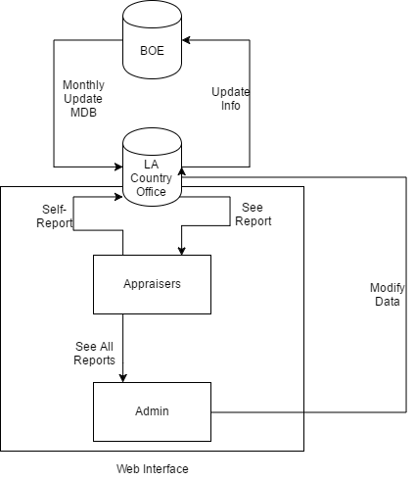

**ER Diagrams**

**Stored Variables**

BOE variables:

Annual Requirement:

* Last Name, First Name, Middle Name, Cert. No., County Code, County Name, Temporary Cert. Date, Perm. Cert. Date, ADV Cert. Date, Current Status, Status, Cert. Type, Fiscal Year, Earned Hours, Required Hours, Current year Balance, Prior year balance, Carry to year 1, Carry to year 2, Carry to year 3, Carry forward total

Details

* County Code, County Name, Certification No., Last Name, First Name, Middle Name, Fiscal Year, End Date, Course, Location, Grade, Hours Earned

Summary

* County Code, County Name, Fiscal Year, Last Name, First Name, Middle Name, Cert. No., Auditor, Carry Forward, Certificate Type

LAC variables:

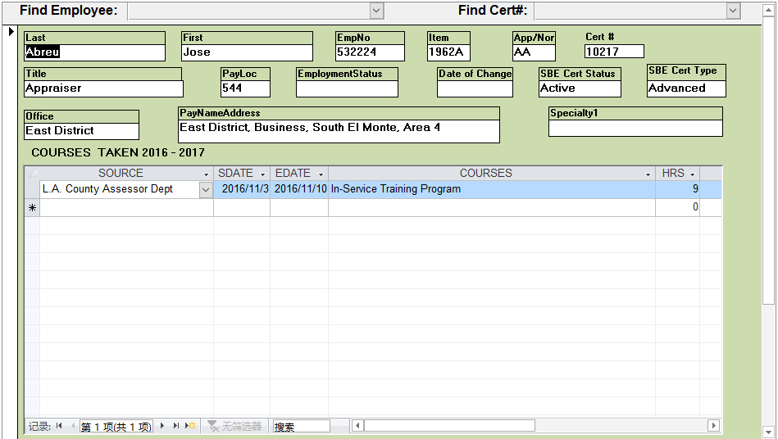

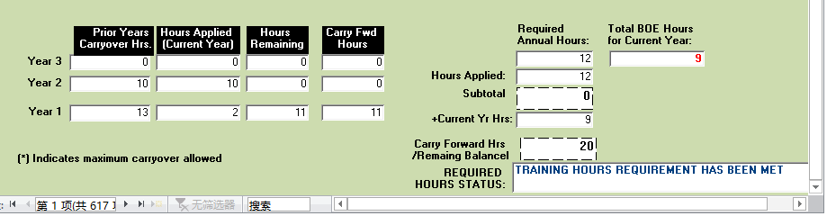

PDF

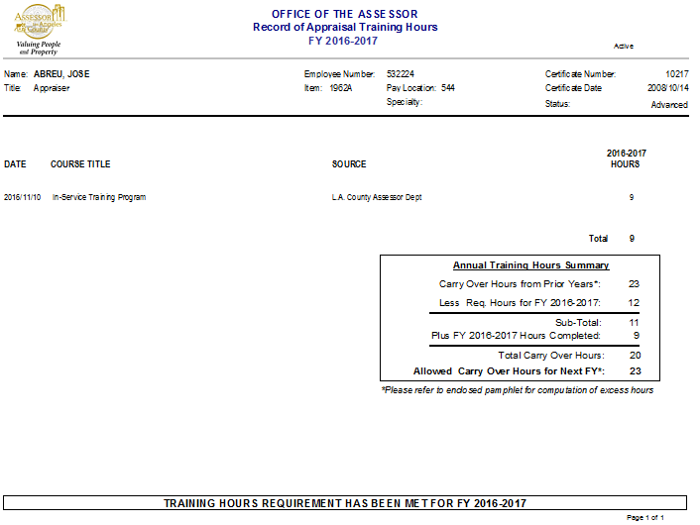

**Extendibility**

* Other employees (without certification number)
* Variables from LA county Assessor's office

**Normalization**

* Database normalization, or simply normalization, is the process of organizing the columns (attributes) and tables (relations) of a relational database to reduce data redundancy and improve data integrity. Normalization is also the process of simplifying the design of a database so that it achieves the optimal structure. It was first proposed by Edgar F. Codd, as an integral part of a relational model. (Wikipedia)

**Edge cases/possible problems with data and Validation**

* Bad Data (Typographical Errors)
* Duplication
* Input Field Standardization
* Employee ID doesn’t match name

**UI Functionality**

* Self-Reporting/Updating information such as classes, personal data

**Design**

1. How to migrate existing data into SQL
   1. Third party
   2. Write a script
2. Frontend to backend connection
   1. PHP
3. Monthly updated BOE data → Our SQL server
   1. Keep master copy, data validation, migrate BOE → SQL
   2. Scrap local SQL copy every time then create new data from BOE
4. Data normalization, we need to analyze database first before